Student Name: Ziggy Greg Uwas

Student ID: 202537366

Title: Resume Classification using Natural Language Processing

Word Count: 3,299



- Definition
This project focuses on building a resume classification system using Natural Language Processing (NLP) techniques to automatically categorize resumes into categories that correspond to job roles such as Data Science, Human Resources, etc. The task is a multi-class text classification problem where textual resume data is transformed into numerical representations and used to train machine learning and deep learning models.

- Scope
This project tackles a core NLP challenge: classifying resumes into professional categories where semantic overlap between fields makes accurate distinction difficult. Categories such as Finance and Banking, or Consultant and Business Development, share substantial vocabulary, requiring models to capture subtle contextual differences rather than surface level keyword patterns.

To address this, the project applies NLP preprocessing techniques to clean and represent resume text, then systematically compares four models Multinomial Naïve Bayes and XGBoost as traditional ML approaches, and Bidirectional LSTM and GRU as deep learning alternatives. Each model is evaluated under two feature representations: TF-IDF, a sparse frequency-based method, and GloVe, a dense pre-trained embedding establishing which model and representation combination yields the strongest classification performance.

- Importance

The average time recruiters spend reading resumes is between six and seven seconds (Ladders, 2018). In such a scenario, errors become costly since a skilled candidate who is mistakenly classified to a wrong pool will have lost his/her chance through no fault of their own, while the recruiter will be wasting precious time sorting through resumes that do not meet the job requirements.

Despite the scale of this problem, most NLP studies on resume classification either work with a small number of broad categories or evaluate a single model in isolation. The problem of classifying semantically similar categories becomes a problem because terms like management and communication are found in almost all resumes irrespective of the profession. This project seeks to solve this problem through benchmarking different machine learning models on 24 categories.

Background Review
Early work by Ali et al. (2022) applied preprocessing methods such as TF-IDF and Bag-of-Words with classifiers including SVM, Naive Bayes, KNN, and Random Forest. Their results showed that SVM achieved up to 98% accuracy, demonstrating the effectiveness of traditional models when supported by strong feature engineering. However, these approaches are limited in capturing semantic meaning and depend heavily on structured datasets.
According to Pal et al. (2022), Random Forest, SVM, and Naive Bayes algorithms were tested using the TF-IDF approach on a dataset of 10,000 entries sourced from Indeed, Glassdoor, and Kaggle across 25 job categories. The highest accuracy was provided by Random Forest at 70%, better than that of Naive Bayes (45%) and SVM (60%). The comparatively low peak accuracy suggests that bag-of-words representations discard important contextual information present in resume text
Similarly, Upadhye (2023) evaluated multiple machine learning models using metrics such as precision, recall, and F1-score, highlighting that ensemble and tree-based models perform competitively. Despite this, the study still relied on surface-level representations, limiting deeper contextual understanding.
More recent research by Chaudhary and Sharma (2025) introduced semantic approaches using transformer-based models such as LLaMA3, which enable contextual understanding of skills and terminology. While traditional models achieved 84–86% accuracy, the transformer-based approach exceeded 92% accuracy, showing improved performance in handling unstructured text, though at higher computational cost.
Further advancements were presented by M’haouach et al. (2026), who combined TF-IDF, DistilBERT, and LLaMA3.1 embedding with machine learning classifiers and applied text augmentation. Their model achieved approximately 99% accuracy, demonstrating the strength of combining semantic embeddings with robust classification techniques, although results depend on data quality and computational resources.
Overall, the literature shows a clear shift from traditional feature-based methods to semantic, deep learning approaches. While traditional models remain efficient baselines, modern embedding-based methods provide superior performance by capturing contextual meaning. This supports the approach of this project, which compares both traditional and deep learning models for resume classification.
- SMART Objective
- Specific: Build and evaluate traditional ML and deep learning models for classifying resumes into 24 categories, comparing TF-IDF and GloVe features across 12 configurations.

- Measurable: Evaluate using accuracy, weighted F1, balanced accuracy, and misclassification count, targeting >85% accuracy in at least one model.
- Achievable: Use 4,966 labelled resumes, existing preprocessing tools (spaCy, NLTK, scikit-learn), and pretrained GloVe embeddings.
- Relevant: Investigates when pretrained embeddings outperform traditional TF-IDF in NLP classification tasks.
- Time-bound: Complete all development and evaluation within the Term 2 deadline.

- Dataset
The dataset used in this study was obtained from Kaggle and consists of a combination of structured and unstructured textual resume data collected from two sources: a CSV file and a set of PDF documents. The CSV dataset contains 2,484 labelled resumes with two key attributes: the resume text (resume_str) and its corresponding job category. To enrich the dataset and improve diversity, an additional 2,483 resumes were extracted from PDF files organised into category-specific folders, where each folder represents a distinct job domain.
The PDF resumes were processed using a text extraction pipeline, where the textual content of each document was extracted and labelled based on its folder category. Both datasets were then merged to form a combined dataset of 4,967 resumes across 24 job categories (classes), creating a more comprehensive and realistic representation of real-world recruitment data. The dataset is entirely textual in nature, making it directly suitable for NLP tasks, However, the dataset exhibits moderate class imbalance. Majority categories such as IT, HR, and Chef contain approximately 200–240 documents each, while minority categories such as Agriculture (63 PDF documents), BPO, and Automobile contain substantially fewer records.

7. Exploratory Data Analysis
7.1 Preprocessing Procedures
All preprocessing steps were fitted on the training set only and applied to the test set using those fitted parameters, preventing data leakage.
Step 1 — Text Cleaning
Step 2 — Tokenisation
Step 3 — Stopword Removal
Step 4 — Lemmatisation

Step 5 — Vectorisation:

No resampling strategy (e.g., SMOTE) was applied, allowing class imbalance effects to be observed honestly across all model configurations.

7.2 Visualisations
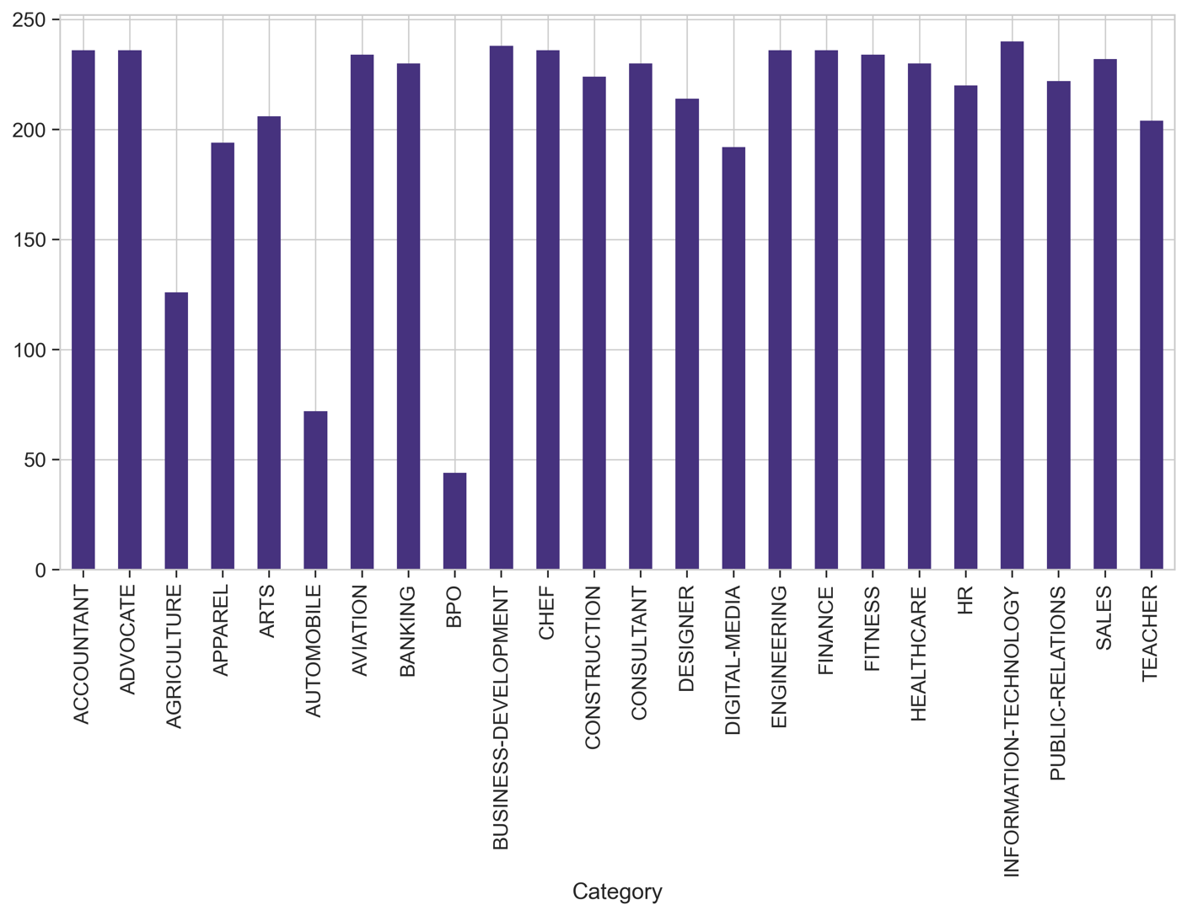
Fig 1: Distribution of Resume Across 24 Job Categories

CATEGORIES | COUNTS
INFORMATION-TECHNOLOGY | 240
BUSINESS-DEVELOPMENT | 238
ADVOCATE | 236
CHEF | 236
FINANCE | 236
ENGINEERING | 236
ACCOUNTANT | 236
FITNESS | 234
AVIATION | 234
SALES | 232
HEALTHCARE | 230
CONSULTANT | 230
BANKING | 230
CONSTRUCTION | 224
PUBLIC-RELATIONS | 222
HR | 220
DESIGNER | 214
ARTS | 206
TEACHER | 204
APPAREL | 194
DIGITAL-MEDIA | 192
AGRICULTURE | 126
AUTOMOBILE | 72
BPO | 44

Table 1: A clearer representation of the total counts per job category

The above table and bar chart of category frequencies confirms moderate class imbalance across the 24 categories.

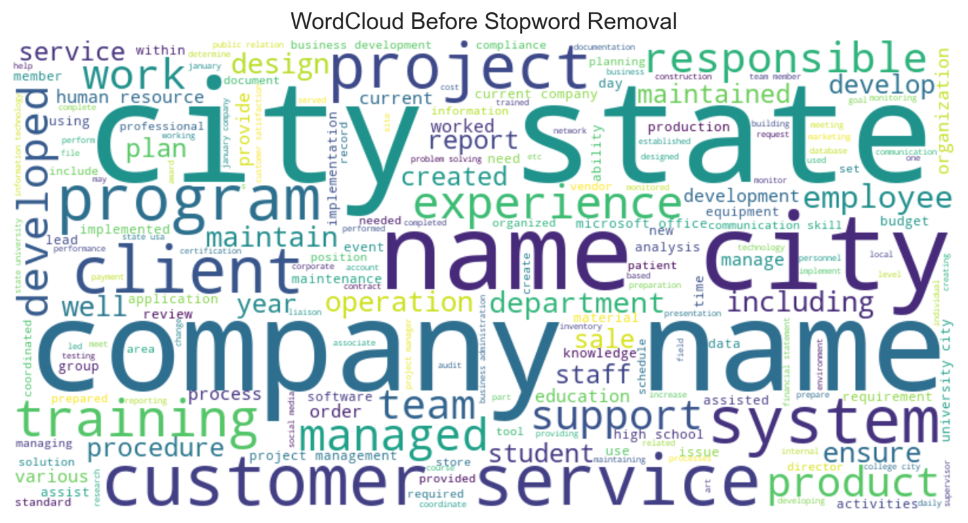

Fig 2: Word Cloud of Resume Text Displaying Most Frequently Used Words

7.3 Baseline Model
Multinomial Naive Bayes with TF-IDF features was selected as the baseline model based on evidence from the background review. Ali et al. (2022) demonstrated that MNB achieved 94.8% accuracy on a comparable resume classification task using TF-IDF features, establishing it as a well-validated baseline for this class of NLP problem. Its simplicity, interpretability, and proven performance on high-dimensional sparse text data make it the appropriate starting point — any more complex model evaluated in this study must demonstrate a clear improvement over this threshold to justify its additional computational cost.

8 Traditional Machine Learning Methods
This section discusses the machine learning models that were chosen and why they were chosen. Two ML models were chosen
i) MNB
ii) XGBOOST

- Multinomial Naive Bayes

Multinomial Naive Bayes (MNB) is a probabilistic classifier based on Bayes’ theorem that calculates the probability of a document belonging to each class given the words it contains. It assumes each word contributes independently to the classification decision ignoring word order and context. Despite this simplification, MNB is well-suited to sparse, high-dimensional TF-IDF feature spaces and was selected as the baseline model because it is the most widely established method for multi-class text classification, providing a clear performance threshold that all subsequent models must exceed (McCallum and Nigam, 1998).

Strengths | Weakness
Computationally efficient and fast to train on 5,000  TF-IDF features | The independence assumption is violated in resume text — related terms like machine and learning are treated as unrelated
Naturally suited to sparse, high-dimensional text representations | Cannot capture word order or phrase-level patterns
Highly interpretable | Struggled on semantically overlapping categories, achieving only 64.5% test accuracy (in this project)
Table 2: Strengths and Weaknesses of Multinomial Naïve Bayes

- XGBoost (eXtreme Gradient Boosting)

XGBoost (eXtreme Gradient Boosting) builds a sequence of decision trees where each tree corrects the errors of the previous one, combining all predictions for a final decision. Unlike MNB, it captures complex non-linear interactions between TF-IDF features without assuming feature independence. XGBoost was chosen because it represents the strongest traditional machine learning approach for sparse text features, allowing a direct evaluation of whether ensemble complexity justifies the performance gain over a probabilistic baseline (Chen and Guestrin, 2016).

Strengths | Weakness
Captures non-linear feature interactions that MNB cannot | Achieved 100% training accuracy, indicating complete memorisation of training data
Robust to irrelevant features through natural tree-splitting | Less interpretable than MNB without additional explainability tools
Achieved a high test accuracy — the highest of all models evaluated | Hyperparameter tuning produced only marginal gains, suggesting a TF-IDF performance ceiling
Table 3: Strengths and weaknesses of XGBoost

8.1 Comparison

 | Naïve Bayes | XGBoost
Approach | Probabilistic | Ensemble trees
Interpretability | High | Low
Training Speed | Very fast | Moderate
Handles Imbalance | Poorly | Better
Table 4: Comparison between XGBoost and MNB

9. Deep Learning Methods

This section discusses the deep learning models chosen for this project and why they were chosen. Two deep learning models were chosen, namely:

- BiLSTM
- GRU

- Bidirectional Long Short-Term Memory (BiLSTM)

BiLSTM processes text sequences in both forward and backward directions simultaneously, producing richer contextual representations than a standard LSTM. It addresses the vanishing gradient problem through input, forget, and output gates that selectively retain information across long sequences. BiLSTM was chosen because resume documents are long and discriminative terms can appear anywhere, bidirectional processing ensures no positional context is lost (Schuster and Paliwal, 1997).

Strengths | Weakness
Captures sequential context in both directions, producing richer word representations than unidirectional models | Although it achieved a high accuracy, the accuracy and loss plot indicate that it overfitted
Handles long resume documents effectively through its gating mechanism | Learns embeddings from scratch, requiring sufficient data to build meaningful word representations
Achieved high test accuracy — strongest deep learning result on the shared test set | Computationally expensive due to bidirectional processing — slowest model to train in this study
Table 5: Strengths and Weaknesses of bilstm

- Gated Recurrent Unit (GRU)

GRU is a simplified recurrent neural network that uses two gates, a reset gate and an update gate, to control how much past information is retained or discarded at each time step. It achieves comparable performance to LSTM with fewer parameters, making it computationally more efficient. In this project, the GRU was initialised with pretrained GloVe embeddings rather than learning word representations from scratch, providing the model with pre-learned semantic knowledge of word relationships before training began. GRU was chosen to evaluate whether a lighter, more efficient architecture combined with pretrained embeddings could match or exceed the BiLSTM (Cho et al., 2014).
Table 6: Strengths and Weaknesses of GRU

Strengths | Weakness
Fewer parameters than BiLSTM — faster to train while maintaining competitive performance | Unidirectional — processes text in one direction only, potentially missing backwards contextual dependencies
Highly stable training.  training and validation accuracy converged closely throughout all 20 epochs | Frozen GloVe embeddings constrained the model’s ability to adapt to resume-specific vocabulary, producing lower performance than the fine-tuned variant
Pretrained GloVe embeddings provide semantic word knowledge, reducing the data requirement for learning meaningful representations | Slower to converge than the bilstm. required 20 epochs to reach 89% compared to BILSTM

9.1 Comparison

 | BiLSTM | GRU
Architecture | Bidirectional,3 gates | Unidirectional, 2 gates
Embeddings | Learned from scratch | Pretrained GloVe
Overfitting | Yes, from Epoch 4 | No, lines converge throughout
Training Stability | Loss diverges after Epoch 2 | Loss converges smoothly across 20 epochs
Convergence Speed | Slow, embeddings learned from scratch | Faster per epoch, pretrained glove gave immediate head start
Table 7: Comparison between Bilstm and Gru

10. Implementation and Refinement

10.1 Libraries and Tools
The following libraries were used to build, train, and evaluate all pipelines:

Libraries | Uses
Pandas and NumPy | Data loading, manipulation and numerical operations
pdfplumber | Extracting raw text from pdf resume documents
NLTK | tokenisation and stopword list construction
spaCy (en_core_web_sm) | lemmatisation and part-of-speech tagging
scikit-learn | TF-IDF vectorisation, Label Encoding, train/test splitting, Naïve Bayes, Grid Search, and evaluation metrics
XGBoost | gradient boosted tree classifier for multi-class text classification
TensorFlow / Keras | building, compiling, and training the BiLSTM and GRU deep learning models
Matplotlib / Seaborn | visualizing training curves, confusion matrices, and class distributions
Table 8: Libraries and Tools used

10.2 Pipeline Procedures
Machine Learning:

- Load and merge CSV (2,484 records) and PDF (2,483 records) sources into a combined dataset of 4,966 documents
- Clean text via clean_text () — removing URLs, special characters, and whitespace; convert to lowercase
- Tokenise, remove stopwords, and lemmatise — fitted on training data only to prevent data leakage
- Apply stratified 80/20 train/test split (3,972 training / 994 test samples)
- Build TF-IDF features: fit on training set, produce matrices of shape (3,972 × 5,000) and (994 × 5,000)
- Build GloVe mean-pooled features (3,972 × 100) and (994 × 100); scale to [0,1] for Naïve Bayes using MinMaxScaler
- Encode labels via Label Encoder for XGBoost; train and evaluate all eight ML model configurations

10.3 Deep Learning Pipeline:

• Convert cleaned text to integer sequences (Keras Tokenizer, fitted on training data only)
• Pad sequences to fixed length (dynamic for BiLSTM, 300 tokens for GRU)
• Encode labels into integers (LabelEncoder)
• Initialize GRU embedding layer with pretrained GloVe vectors (100D)
• Compile models (Adam optimizer, sparse categorical cross-entropy)
• Apply early stopping (monitor validation loss)
• Evaluate models (accuracy, weighted F1, balanced accuracy)

10.4 Refinement Strategy 1 — Hyperparameter Tuning
Hyperparameter tuning was applied to MNB and XGBoost.
For MNB, reducing alpha (1.0 to 0.001) increased sensitivity to observed terms, while disabling class priors addressed class imbalance.
For XGBoost, increasing trees (250), reducing depth (5), lowering learning rate (0.08), and applying subsampling (0.9) improved stability and controlled complexity.
Parameters were selected via manual tuning due to computational constraints.

10.5 Refinement Strategy 2 — Transfer Learning and Regularisation
GloVe embeddings (100D) were used to introduce semantic knowledge.
For traditional ML, document vectors were created via mean-pooling.
For the GRU models, GloVe vectors were loaded into the embedding layer and evaluated under two conditions: frozen, where weights remained fixed throughout training, and fine-tuned, where weights were unlocked and allowed to adjust to resume-specific vocabulary during training.
Regularisation was applied to BiLSTM using dropout (0.3) and reduced units (64 to 32) to address overfitting.
While this reduced overfitting, accuracy dropped (93.36% to 92.15%), suggesting over-regularisation limited performance.

∙

11. Evaluation
11.1 Metrics

Every model is evaluated using four metrics:
- Accuracy
- F1 Score
- Balanced Accuracy
- Misclassification Count

Model | Type | Word  representation | Accuracy | F1 | Balanced Accuracy | Misclassified
MNB (TF-IDF Baseline) | TML | TF-IDF | 0.6449 | 0.613 | 0.5911 | 353
MNB (TF-IDF Tuned) | TML | TF-IDF | 0.7505 | 0.7494 | 0.7329 | 248
MNB GloVe Baseline | TML | GLOVE | 0.5050 | 0.4869 | 0.4610 | 492
MNB GloVe Tuned | TML | GLOVE | 0.4909 | 0.4918 | 0.4638 | 506
XGBOOST Baseline | TML | TF-IDF | 0.9598 | 0.9595 | 0.9476 | 40
XGBOOST TUNED | TML | TF-IDF | 0.9588 | 0.9585 | 0.9465 | 41
XGBOOST Baseline | TML | GLOVE | 0.8924 | 0.8926 | 0.8848 | 107
XGBOOST  Tuned | TML | GLOVE | 0.9034 | 0.9033 | 0.8948 | 96
BiLSTM Baseline | DL | Learned Embeddings | 0.9336 | 0.9328 | 0.9267 | 33
BiLSTM  Regularised | DL | Learned Embeddings | 0.9215 | 0.9209 | 0.9053 | 39
GRU  Baseline | DL | GLOVE (Frozen) | 0.8773 | 0.8709 | 0.8237 | 61
GRU  Tuned | DL | GLOVE (fine-tuned) | 0.8732 | 0.8650 | 0.8182 | 63

Table 8: Full Model Performance Summary- TML and DL (TML =TRADITIONAL ML AND DEEP LEARNING)

11.2 Visuals of the results

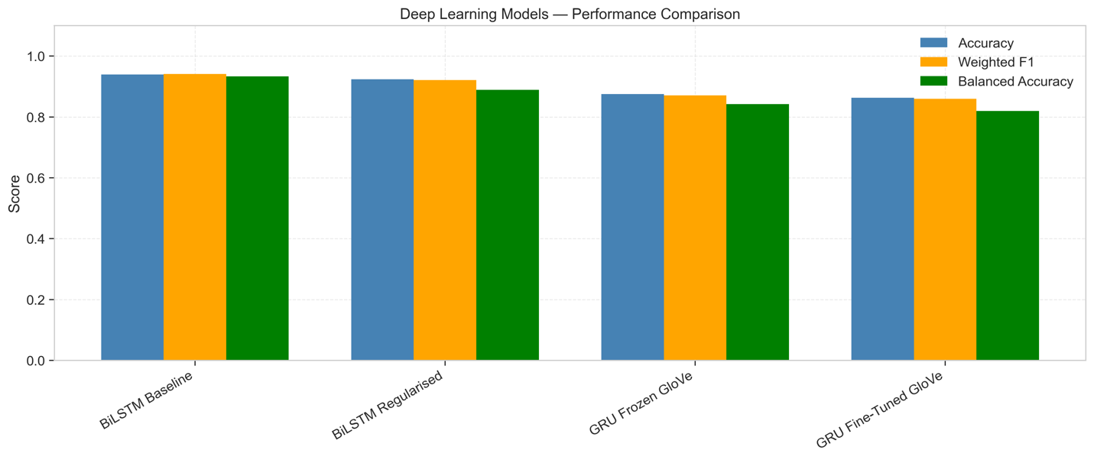
Fig 3: Deep Learning Models- Performance Comparison

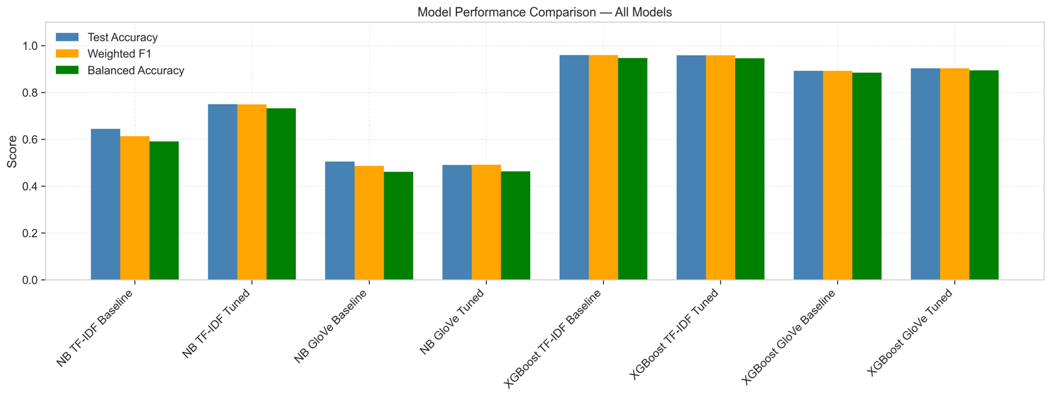
Fig 4: Traditional ML Models- Performance Comparison

11.3 Effect of Hyperparameter Tuning
Naive Bayes:
Tuning improved TF-IDF accuracy from 64.49% to 75.05% (+10.56pp), reducing misclassifications (353 → 248). Lower alpha increased sensitivity to key terms, while removing class priors helped with imbalance. In contrast, GloVe performed poorly (~50%) and did not improve with tuning, as dense vectors lose the sparse signals Naive Bayes relies on.
XGBoost (TF-IDF):
Minimal change after tuning (95.98% → 95.88%), indicating the baseline was near optimal. However, with GloVe, tuning improved performance (89.24% → 90.34%), showing greater benefit when feature representations differ.

11.4 Effect of Regularisation and Fine-Tuning
BiLSTM:
Regularisation reduced overfitting (via dropout, fewer units, early stopping) but slightly lowered accuracy (93.36% to 92.15%) and increased misclassification (33 to 39), highlighting a trade-off between generalisation and performance.
GRU (GloVe):
Frozen embeddings outperformed fine-tuned ones (87.73% vs 87.32%), suggesting pretrained GloVe was already well-suited, while fine-tuning slightly degraded performance.

11.5 Comparison to the Wider Literature
Ali et al. (2022) reported high accuracy (94.8% Naive Bayes, 99.6% SVM) on a smaller, less complex dataset (962 resumes, 25 categories). In contrast, this study uses a larger and more challenging dataset (4,966 resumes, 24 overlapping categories), leading to lower baseline performance (64.5%–75.1%) due to increased semantic ambiguity.
Despite this, XGBoost achieved 95.98% accuracy, showing competitive performance on a harder task (Chen and Guestrin, 2016). Unlike prior work, this study also evaluates deep learning models, with BiLSTM (93.38%) and fine-tuned GRU (87.32%) demonstrating strong performance.
Overall, this study extends existing research by applying both traditional and deep learning models to a more complex dataset using multiple evaluation metrics.

Conclusion

This project evaluated twelve model configurations across four model families for automated resume classification across 24 semantically overlapping occupational categories.
XGBoost (TF-IDF) is the strongest overall model at 95.98% accuracy (F1: 0.9595, balanced accuracy: 0.9476), as observed in (fig 4). The baseline BiLSTM (93.36%, F1: 0.93.28) is the strongest deep learning model. As seen in (Fig 3)

Three key lessons emerge. First, tuning is only effective when a gap exists, Naive Bayes improved from 64.49% to 75.05% while XGBoost was already at its ceiling. Second, regularisation must be calibrated, the regularised BiLSTM dropped from 93.36% to 92.15% despite reducing overfitting

(Harvard referencing style was used for this paper)
References
Ali, I., Mughal, N., Khand, Z.H., Ahmed, J. and Mujtaba, G. (2022) 'Resume Classification System using Natural Language Processing and Machine Learning Techniques.' Mehran University Research Journal of Engineering and Technology, 41(1), pp.65–79.
Chaudhary, N. and Sharma, P. (2025) 'High-Scale ATS and Semantic Resume Filtering using Django, NLP, and LLaMA3-Groq Models.' International Journal for Research in Applied Science and Engineering Technology, 13(V).
Chen, T. and Guestrin, C. (2016) 'XGBoost: A Scalable Tree Boosting System.' Proceedings of the 22nd ACM SIGKDD International Conference on Knowledge Discovery and Data Mining, pp.785–794.
Cho, K., Van Merriënboer, B., Gulcehre, C., Bahdanau, D., Bougares, F., Schwenk, H. and Bengio, Y. (2014) 'Learning Phrase Representations using RNN Encoder-Decoder for Statistical Machine Translation.' Proceedings of the 2014 Conference on Empirical Methods in Natural Language Processing (EMNLP), pp.1724–1734.
Ladders. (2018) 'Eye-Tracking Study: Recruiters Look at Resumes for 7.4 Seconds.' [online] Available at: https://www.theladders.com/career-advice/you-only-get-6-seconds-of-fame-make-it-count [Accessed April 2026].
McCallum, A. and Nigam, K. (1998) 'A Comparison of Event Models for Naïve Bayes Text Classification.' Proceedings of the AAAI-98 Workshop on Learning for Text Categorization, pp.41–48.
M'haouach, M., Choukhairi, M., Alami, H., Bouraqqadi, H., Fardouss, K. and Berrada, I. (2026) 'Towards Smarter Hiring Solutions: Artificial Intelligence-Driven Resume Classification with Advanced Embedding Techniques.' Multimedia Tools and Applications, 85(16).
Pal, R., Shaikh, S., Satpute, S. and Bhagwat, S. (2022) 'Resume Classification using various Machine Learning Algorithms.' ITM Web of Conferences, 44, 03011.
Pennington, J., Socher, R. and Manning, C.D. (2014) 'GloVe: Global Vectors for Word Representation.' Proceedings of the 2014 Conference on Empirical Methods in Natural Language Processing (EMNLP), pp.1532–1543.
Schuster, M. and Paliwal, K.K. (1997) 'Bidirectional Recurrent Neural Networks.' IEEE Transactions on Signal Processing, 45(11), pp.2673–2681.
Upadhye, A. (2023) 'Automating Resume Classification: Leveraging NLP and AI for Efficient Candidate Screening.' International Journal of Computer Applications, 185(40), pp.46–50.

